Cú pháp

File pom

<dependencies>  
 <!-- https://mvnrepository.com/artifact/org.seleniumhq.selenium/selenium-java -->  
 <dependency>  
 <groupId>org.seleniumhq.selenium</groupId>  
 <artifactId>selenium-java</artifactId>  
 <version>4.9.0</version>  
 </dependency>  
  
 <!-- https://mvnrepository.com/artifact/io.github.bonigarcia/webdrivermanager -->  
 <dependency>  
 <groupId>io.github.bonigarcia</groupId>  
 <artifactId>webdrivermanager</artifactId>  
 <version>5.3.2</version>  
 </dependency>  
  
 <!-- https://mvnrepository.com/artifact/org.slf4j/slf4j-simple -->  
 <dependency>  
 <groupId>org.slf4j</groupId>  
 <artifactId>slf4j-simple</artifactId>  
 <version>1.7.36</version>  
 <scope>test</scope>  
 </dependency>

Buổi 16

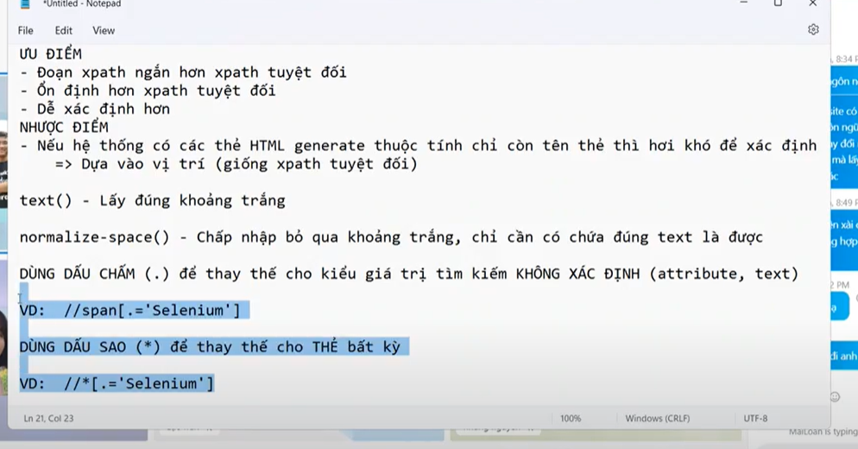

TestNG la 1 farmework

Selenium là 1 thư viện

